**10 of the Greatest Chess Grandmasters Who Ever Lived**

Chess, often referred to as the "Game of Kings," has a storied history that spans centuries and continents. At the heart of this intricate and strategic game are individuals whose mastery transcends the ordinary, earning them the prestigious title of Chess Grandmaster. This ebook, "10 of the Greatest Chess Grandmasters Who Ever Lived," embarks on a captivating journey through the lives and achievements of these extraordinary individuals who have left an indelible mark on the rich tapestry of chess history.

**Definition of a Chess Grandmaster**

The title of Chess Grandmaster is not merely symbolic; it signifies the pinnacle of achievement in the world of chess. In this introductory section, we delve into the criteria and significance of being recognized as a Chess Grandmaster. We explore the rigorous process, the intellectual prowess, and the strategic acumen that distinguish these individuals as the elite among chess players. Understanding what it takes to earn this distinction sets the stage for an exploration of the exceptional careers and contributions of the grandmasters to follow.

**Importance of Chess Grandmasters in the History of Chess**

Chess Grandmasters are not just exceptional players; they are the architects of chess evolution. As we uncover how these chess luminaries shaped the course of the game, we see how their innovative strategies, groundbreaking theories, and unparalleled dominance on the board have not only influenced generations of players but have also contributed to the global recognition and admiration of chess as a sport and intellectual pursuit. The impact of these grandmasters extends beyond the chessboard, permeating the realms of culture, philosophy, and education.

**Purpose of the Book**

The purpose of "10 of the Greatest Chess Grandmasters Who Ever Lived" goes beyond a mere recollection of chess history. It is a celebration of genius, a tribute to those who have elevated the game to an art form. By exploring the top 10 fundamentals of these grandmasters, we aim to provide you with an engaging summary that highlights the diversity of playing styles, the cultural contexts in which they thrived, and the enduring lessons their games offer.

Whether you are an aspiring chess player seeking inspiration, a seasoned enthusiast eager to revisit the triumphs of legends, or a curious mind intrigued by the intersection of intellect and competition, this eBook invites you to embark on a fascinating exploration of chess excellence. Join us as we unravel the wisdom of these 10 individuals whose brilliance has left an indelible mark on the world of chess.

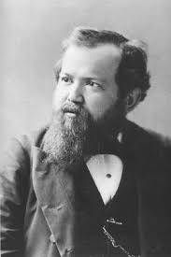  
**Wilhelm Steinitz's Chess Wisdom: Unveiling the Strategic Secrets**

Chess, to me, is not merely a game; it is a symphony of intellect and strategy, a battlefield where minds engage in a dance of wits. My name is Wilhelm Steinitz, the first World Chess Champion, and I invite you to explore the profound principles that have guided my games and forged my legacy.

1. Center Control:

- The heart of the chessboard is the center. Seize it with conviction, for control here is control over the destiny of the entire game.

2. Pawn Structure:

- Understand the language of pawns. They are the architects of positions, shaping the battlefield. A well-structured pawn formation is a fortress that dictates the ebb and flow of the game.

3. King Safety:

- The king is not just a piece; it's the royal anchor. Keep it sheltered, cloak it in safety, and let no tempest disturb its repose.

4. Prophylaxis:

- Anticipate your opponent's plans. Engage in prophylactic thinking, disrupting their schemes before they materialize.

5. Piece Coordination:

- Harmony among pieces is the melody of victory. Let your pieces converse, each complementing the other in a strategic symphony.

6. Initiative:

- Grasp the initiative and wield it with precision. Like a conductor guiding an orchestra, direct the flow of the game towards your desired crescendo.

7. Exchange Strategy:

- Every capture has repercussions. Master the art of exchanges, knowing when to trade and when to maintain the tension for greater strategic leverage.

8. Endgame Prowess:

- The endgame is the apotheosis of understanding. Hone your endgame skills, for in simplicity lies the essence of victory.

9. Time Management:

- Time is a valuable resource. Use it wisely, with purpose and efficiency. Speed alone is not the essence; it's the rhythm that matters.

10. Psychological Warfare:

- Understand the psychology of your adversary. Chess is not only about moves on the board but about the minds behind them. Exploit weaknesses, induce errors, and emerge victorious not just in position but in the psychological realm.

These principles are not mere guidelines; they are the essence of my strategic philosophy. As you delve into the intricacies of chess, let these principles be your compass, guiding you through the labyrinth of possibilities. May your games be a testament to the enduring brilliance of the game we all cherish.

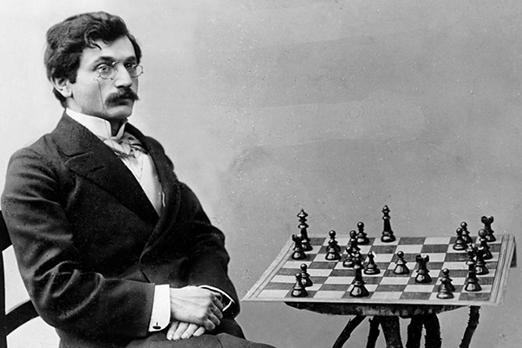

**Emanuel Lasker’s Chess Manifesto: Unraveling the Sublime Artistry**

In the realm of chess, I, Emanuel Lasker, the second World Chess Champion, beckon you to unravel the profound strategies that defined my era. Chess, to me, is not a mere game; it is a canvas for the expression of profound ideas and the harmonious interplay of intellect. Embark on this journey as I unveil my top 10 tips and tricks, weaving a tapestry of wisdom to guide you through the complexities of the chessboard.

1. Dynamic Balance:

- Seek harmony in imbalance. Allow your position to flow between attack and defense, adapting to the ebb and flow of the game's dynamics.

2. Prophetic Vision:

- Grasp the chessboard as a seer gazes into the future. Anticipate your opponent's plans and weave a strategic tapestry that foils their intentions.

3. Positional Harmony:

- The symphony of chess arises from positional harmony. Let your pieces sing in unison, each contributing to the grand orchestration of the game.

4. Maneuvering Mastery:

- Chess is a dance, and your pieces are the dancers. Master the delicate art of maneuvering, guiding them with finesse across the board.

5. Transformational Power of Pawns:

- Pawns are not mere foot soldiers; they are the architects of destiny. Understand their transformative power, for a pawn's advance can reshape the landscape of battle.

6. Endgame Alchemy:

- The endgame is not a destination but a crucible of alchemy. Transform disadvantages into advantages, and grasp victory from the jaws of adversity.

7. Psychological Tenacity:

- Be a psychological maestro. Understand the thoughts that dance behind your opponent's eyes, and use this insight to dictate the tempo of the game.

8. Flexible Planning:

- Plans are not carved in stone; they are sculpted in clay. Embrace flexibility, adapting your strategy to the evolving nuances of the game.

9. Resourcefulness in Adversity:

- When the tempest of a difficult position descends, find the calm within. Resourcefulness in adversity is the hallmark of a true chess artist.

10. Intellectual Resilience:

- Chess is a battle of minds. Cultivate intellectual resilience, for victory often belongs not to the strongest player but to the one who endures with unwavering determination.

These principles are not stagnant rules but living philosophies, echoing the ethos of my games. As you navigate the intricate paths of chess, let these insights be your guiding constellations. May your games resonate with the sublime artistry that defines the spirit of chess—the spirit that I, Emanuel Lasker, sought to immortalize on the 64 squares.

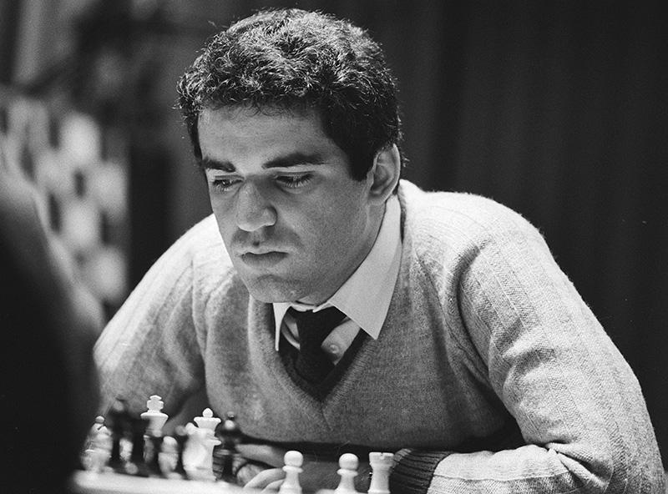

**Garry Kasparov's Chess Mastery: Decoding the Grand Strategy**

Greetings, fellow chess enthusiasts. I am Garry Kasparov, the 13th World Chess Champion, and I invite you to embark on a journey into the depths of strategic brilliance that defined my reign. Chess is not a static battlefield; it's a living, breathing entity where creativity and foresight shape destinies. Join me as we uncover the top 10 tips and tricks that encapsulate the essence of my approach to the royal game.

1. Aggressive Dynamics:

- Seize the initiative, dictate the tempo, and plunge into the fray with aggressive dynamics. Make every move a declaration of intent, keeping your opponent on the back foot.

2. Kingdom of Calculation:

- In the kingdom of calculation, precision reigns supreme. Sharpen your analytical prowess, visualize variations, and navigate the labyrinth of possibilities with unyielding precision.

3. Opening Innovations:

- The opening is not just a prelude; it's an opportunity for innovation. Develop a repertoire that surprises and disrupts, giving you a strategic edge from the very first move.

4. Relentless Pressure:

- Apply unrelenting pressure on your opponent. Create a strategic vise, squeezing them into positions where every move is a concession.

5. Tactical Finesse:

- Tactics are the heartbeat of chess. Hone your tactical finesse, spotting combinations and exploiting weaknesses with surgical precision.

6. Proactive Piece Play:

- Pieces are your instruments of conquest. Play them proactively, coordinating their movements to dominate the board and restrict your opponent's options.

7. Adaptive Strategy:

- Strategy is a dynamic concept. Adapt your plans to the evolving demands of the position, staying flexible and capitalizing on changing imbalances.

8. Endgame Precision:

- The endgame is the culmination of strategic mastery. Navigate the complexities with precision, converting advantages into decisive outcomes.

9. Psychological Warfare:

- The mind is a powerful weapon. Engage in psychological warfare, disrupting your opponent's composure and exploiting the mental battleground.

10. Continuous Learning:

- The pursuit of mastery knows no bounds. Embrace a mindset of continuous learning, dissecting your games, and extracting lessons from every move.

These principles are not mere guidelines; they are the DNA of a strategic mindset that fueled my success. As you traverse the chessboard, let these insights be your guiding lights, illuminating the path to victory. May your games reflect the spirit of audacity and innovation that defines the true essence of chess—the essence I, Garry Kasparov, endeavored to manifest during my reign.

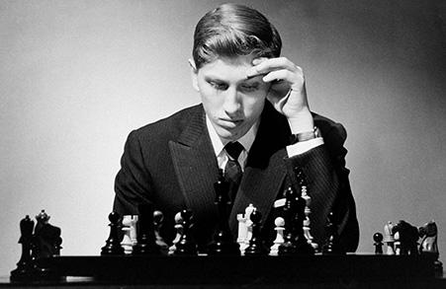

**Bobby Fischer's Chess Revolution: Unleashing Tactical Brilliance**

Hey, chess enthusiasts! I'm Bobby Fischer, the maverick, the provocateur, and I welcome you to a wild ride through the secrets that fueled my unorthodox chess reign. Chess isn't just a game; it's a battle, a struggle for supremacy. Join me as we unravel the top 10 tips and tricks that defined my approach to the board.

1. Controlled Chaos:

- Throw the rulebook out the window; I did. Embrace the chaos, but make it yours. Controlled chaos is the key to keeping opponents off balance and opening up opportunities.

2. Hyper-Modern Openings:

- Traditional openings are for the faint-hearted. Explore the boundaries with hyper-modern openings, luring your opponents into unfamiliar territory where your creativity reigns supreme.

3. Tactical Precision:

- Chess is a brawl, and tactics are your punches. Develop a razor-sharp tactical eye, spotting combinations that catch opponents off guard and leave them dazed.

4. King's Pawn Opening Mastery:

- The King's Pawn Opening is my domain. Master it. It's not just an opening; it's a statement. Control the center, dictate the game, and let the battle unfold on your terms.

5. Fischer Random Chess:

- Shake things up with Fischer Random Chess. Break free from the predictable patterns and revel in the unpredictable beauty of a game that defies convention.

6. Piece Activity over Material:

- Pieces on the board are your warriors. Activate them aggressively, even if it means sacrificing material. It's not about the pieces you have; it's about what they can do.

7. Endgame Intuition:

- The endgame is where the true artist emerges. Cultivate endgame intuition, navigating the complexities with finesse, and transforming seemingly equal positions into winning endgames.

8. Tenacious Defense:

- Defense is an art, not a concession. Become a fortress when under attack, turning the tables on your opponents with a resilient defense that breeds frustration.

9. Psychological Edge:

- Get into your opponent's head. Understand their fears, exploit their weaknesses, and let the psychological battle be your secret weapon.

10. Obsessive Study:

- Obsession is a virtue in chess. Study relentlessly. Analyze your games, delve into openings, and let your passion for improvement drive you to new heights.

These aren't just tips; they're battle cries. As you dive into the chess arena, remember: rules are meant to be broken, patterns are meant to be shattered, and victory belongs to those who dare to rewrite the narrative. Channel the spirit of Fischer, and let your games echo with the revolutionary fervor that defines the heart of chess.

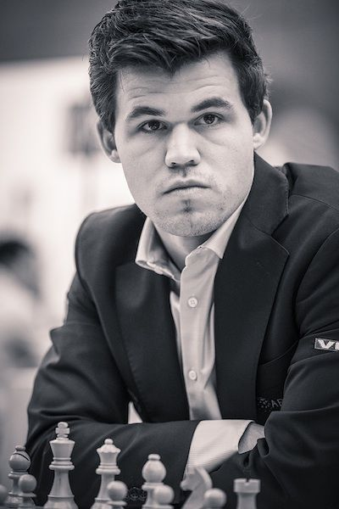

**Magnus Carlsen's Chess Mastery: Navigating the Mind's Arena**

Greetings, chess aficionados! I'm Magnus Carlsen, the reigning World Chess Champion, and I invite you to join me on a journey through the nuanced world of chess. Chess, to me, is not just a game; it's a canvas where intuition, strategy, and creativity converge. Let's delve into the top 10 tips and tricks that define my approach to the board.

1. Universal Control:

- Establish universal dominance on the board. Control key squares, harmonize your pieces, and forge a position where every move contributes to a symphony of strategic coherence.

2. Adaptable Openings:

- Embrace openings that offer flexibility. Let adaptability be your weapon, steering the game into territories where your opponents feel discomfort, while you remain in your element.

3. Endgame Prowess:

- The endgame is my playground. Hone your endgame skills, where precision matters most. Convert the smallest advantages into victories with a refined understanding of the subtleties.

4. Proactive Maneuvering:

- Maneuver with a purpose. Proactive piece play is the key to dominating the board. Each piece should have a role, contributing to a dynamic and forward-looking strategy.

5. Psychological Precision:

- Understand your opponent's mindset. Craft moves that induce discomfort and provoke errors. The psychology of chess is a silent but potent force in shaping the outcome.

6. Dynamic Imbalances:

- Seek imbalances that favor your style. Whether it's pawn structures, piece activity, or king safety, master the art of creating and exploiting dynamic imbalances.

7. Time Management:

- Time is a resource to be wielded wisely. Use it strategically, balancing the clock with purposeful moves. Effective time management ensures control in complex positions.

8. Deep Calculation:

- Delve into the depths of calculation. Analyze variations meticulously, foreseeing the consequences of each move. Precision in calculation is the cornerstone of accurate decision-making.

9. Continuous Learning:

- Cultivate a mindset of perpetual improvement. Learn from every game, acknowledge your weaknesses, and adapt your style. The pursuit of excellence is an ongoing journey.

10. Innovation and Creativity:

- Innovate on the board. Infuse your games with creativity, unveiling new ideas that catch opponents off guard. Chess is an art form, and your games should reflect the beauty of innovation.

These tips aren't commandments; they're principles. As you traverse the chessboard, let intuition guide your hand, and strategy shape your vision. Channel the spirit of Carlsen, and let your games mirror the dynamic and intuitive brilliance that defines the essence of modern chess. May your every move be a step towards mastery and your games, an exploration of the infinite possibilities within the mind's arena.

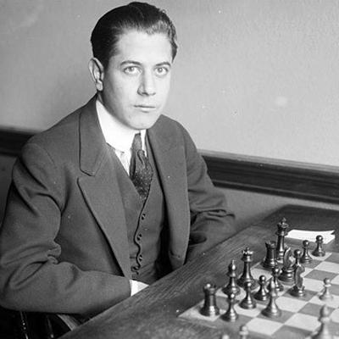

**José Capablanca's Chess Harmony: The Elegant Dance of Strategy**

Greetings, chess enthusiasts! I am José Capablanca, the third World Chess Champion, and I invite you to delve into the refined artistry of chess—a game where simplicity and harmony prevail. Chess, to me, is an elegant dance on the 64 squares, where strategic grace and positional understanding reign supreme. Join me as we uncover the top 10 tips and tricks that epitomize my approach to the royal game.

1. Efficient Development:

- Focus on harmonious piece development. Efficiently bring your pieces into play, ensuring they collaborate seamlessly to control the board's key squares.

2. King Safety as a Priority:

- Guard your king with a vigilant eye. Prioritize king safety from the onset, creating a haven that safeguards your position and facilitates the coordinated movement of your forces.

3. Pawn Structure Awareness:

- Understand the language of pawns. Analyze pawn structures with finesse, recognizing their implications on the position and aligning your pieces accordingly.

4. Piece Coordination:

- Cultivate a symphony among your pieces. Coordination is not a luxury but a necessity. Let each piece complement the other, contributing to the fluidity of your strategy.

5. Endgame Proficiency:

- Mastery in the endgame is the hallmark of a true chess artisan. Develop your endgame skills, where clarity and simplicity prevail, transforming positional advantages into tangible victories.

6. Strategic Outposts:

- Identify and occupy strategic outposts on the board. These key squares serve as bastions from which your pieces exert influence, restricting your opponent's options.

7. Prophylactic Thinking:

- Anticipate your opponent's plans. Engage in prophylactic thinking, disrupting their initiatives and steering the game towards positions where your advantages blossom.

8. Optimal Use of Time:

- Time is a valuable resource; use it judiciously. Avoid unnecessary maneuvers, focusing on moves that contribute to the progression of your strategy and harmonious coordination.

9. Positional Sacrifices:

- Embrace the art of positional sacrifices. Sacrifice material for strategic gains, creating imbalances that disrupt your opponent's harmony and pave the way for a victorious denouement.

10. Patience and Precision:

- Patience is the bedrock of strategy. Execute your plans with precision, avoiding impulsive moves, and let the subtlety of your play be the harbinger of success.

These principles are not just strategies; they are the embodiment of elegance and simplicity. As you embark on your chess journey, let these insights guide you toward a realm where clarity prevails, and each move resonates with the timeless elegance that defines the spirit of José Capablanca. May your games echo the subtle dance of pieces on the board, a testament to the enduring beauty of strategic simplicity.

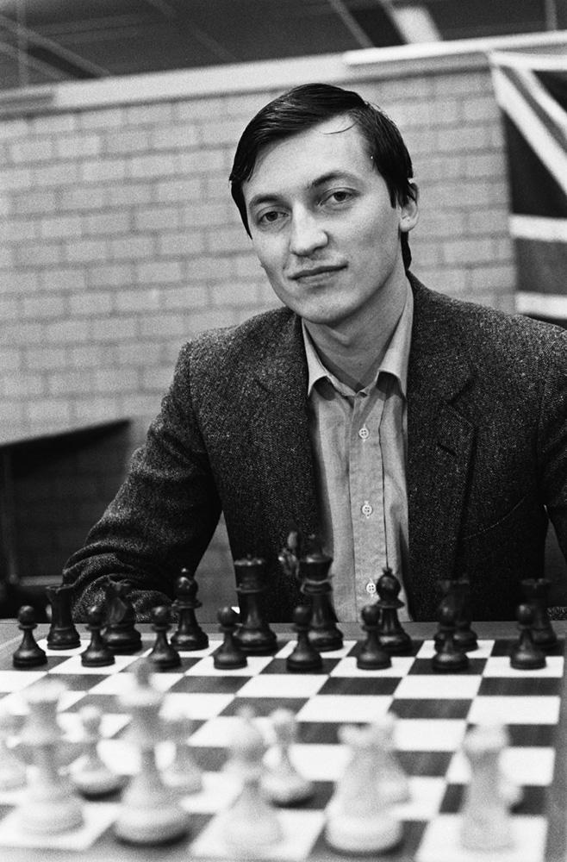

**Anatoly Karpov's Chess Mastery: The Methodical Art of Positional Supremacy**

Greetings, fellow chess enthusiasts. I am Anatoly Karpov, the twelfth World Chess Champion, and I extend an invitation to unravel the disciplined artistry that characterizes my approach to the royal game. Chess, in my view, is a methodical conquest—a strategic ballet that requires precision and unwavering focus. Join me as we explore the top 10 tips and tricks that embody the essence of my chess philosophy.

1. Solid Pawn Structures:

- Establish a solid foundation. Craft pawn structures that withstand scrutiny, providing a robust framework for your pieces and restricting your opponent's counterplay.

2. Pawn Islands Awareness:

- Be mindful of pawn islands on the board. Minimize their number in your camp while maximizing them in your opponent's territory, creating strategic weaknesses to exploit.

3. Positional Patience:

- Patience is a virtue. Play with a positional mindset, gradually improving your position and waiting for the opportune moment to unleash your strategic initiatives.

4. Piece Centralization:

- Centralize your pieces with surgical precision. A centralized army exerts maximum influence, dominating the board and restricting your opponent's freedom of movement.

5. Prophylactic Moves:

- Anticipate your opponent's plans and thwart them with prophylactic moves. Foresight is the key to disrupting their ideas and maintaining control over the strategic landscape.

6. King Safety and Harmony:

- Guard your king meticulously. A secure king forms the core of a harmonious position, ensuring stability and enabling your pieces to coordinate seamlessly.

7. Endgame Expertise:

- Excel in the endgame. Develop a profound understanding of endgame principles, where precise maneuvering and deep calculation transform advantages into decisive victories.

8. Time Management Efficiency:

- Use your time judiciously. Allocate it efficiently, focusing on critical moments and strategic decisions. A well-managed clock is an asset in the battle of ideas.

9. Positional Sacrifices:

- Delve into the realm of positional sacrifices. Sacrifice material for strategic gains, creating imbalances that destabilize your opponent's position and pave the way for victory.

10. Strategic Consistency:

- Maintain strategic consistency throughout the game. Avoid impulsive deviations and adhere to your strategic plan, ensuring that each move aligns with your overarching goals.

These tips are not just tactics; they are the embodiment of methodical brilliance. As you navigate the chessboard, let these insights guide your moves with precision and purpose. May your games reflect the disciplined elegance that defines the spirit of Anatoly Karpov—a spirit rooted in strategic mastery and unwavering positional supremacy.

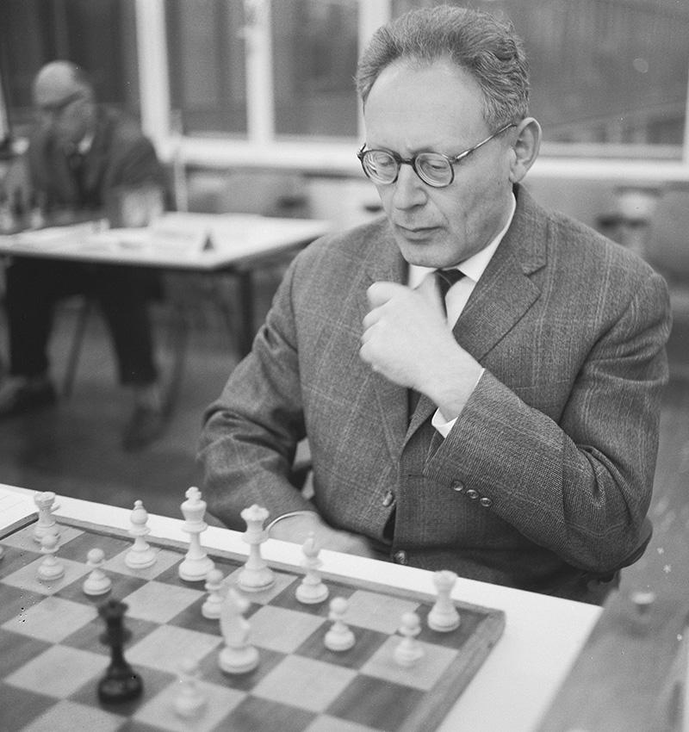

**Mikhail Botvinnik's Chess Pedagogy: A Symphony of Structure and Strategy**

Greetings, chess comrades. I am Mikhail Botvinnik, the sixth World Chess Champion, and I extend an invitation to explore the intricate symphony that is chess—a composition of structure, strategy, and meticulous calculation. Chess, to me, is not a mere game; it is a disciplined pursuit, a strategic endeavor where every move shapes the harmony of the board. Join me as we unravel the top 10 tips and tricks that epitomize my approach to mastering the royal game.

1. Centralized Control:

- Rule the board from the center. Establish control over central squares to dictate the tempo of the game, allowing your pieces to harmonize and exert maximum influence.

2. Pawn Chains and Outposts:

- Craft pawn chains that fortify your position. Seek strategic outposts for your pieces, leveraging pawn structure to restrict your opponent's mobility and dominate key squares.

3. Endgame Precision:

- Excel in the endgame. Develop a profound understanding of pawn endings, converting advantages with precision and elevating your endgame prowess to a level of unmatched finesse.

4. Strategic Pawn Breaks:

- Master the art of strategic pawn breaks. Time them with precision to disrupt your opponent's pawn structure, creating weaknesses that become focal points for your strategic exploitation.

5. Prophylactic Thinking:

- Anticipate your opponent's plans with prophylactic thinking. Strive to neutralize their potential threats before they materialize, maintaining a position of strategic dominance.

6. Piece Coordination:

- Ensure symphony among your pieces. Harmonize their movements, coordinating their efforts to work in unison, and controlling the board like a conductor guiding an orchestra.

7. Control of Open Lines:

- Dominate open lines. Control and occupy open files to unleash the full potential of your rooks, restricting your opponent's counterplay and solidifying your strategic advantage.

8. Strategic Maneuvering:

- Engage in strategic maneuvering. Precisely position your pieces to maximize their impact, creating a canvas where every move aligns with your overarching strategic plan.

9. Time Management Efficiency:

- Utilize time as a strategic resource. Allocate it judiciously, focusing on key moments and critical decisions to maintain control over the evolving dynamics of the game.

10. Innovative Opening Choices:

- Embrace innovative opening choices. Surprise your opponents with strategic novelties, disrupting their preparation and steering the game into positions where your understanding prevails.

These principles are not just guidelines; they are the embodiment of a methodical approach to chess mastery. As you embark on your chess journey, let these insights guide your moves with precision and purpose. May your games reflect the disciplined elegance and strategic brilliance that defines the spirit of Mikhail Botvinnik—a spirit rooted in structure, strategy, and an unwavering commitment to chess excellence.

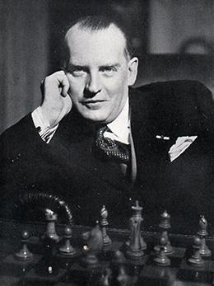

**Alexander Alekhine's Chess Alchemy: A Symphony of Aggression and Imagination**

Greetings, fellow chess enthusiasts. I am Alexander Alekhine, the fourth World Chess Champion, and I beckon you to unravel the enigmatic tapestry that is chess—a canvas where aggression, imagination, and audacity converge. Chess, to me, is not just a game; it is a realm where creativity dances with strategy, and every move is a brushstroke on the canvas of victory. Join me as we delve into the top 10 tips and tricks that encapsulate my daring approach to the royal game.

1. Dynamic Centralization:

- Seize the center dynamically. Engage in tactical skirmishes to centralize your pieces aggressively, creating a battleground where your forces reign supreme.

2. Provocative Pawn Structures:

- Craft provocative pawn structures. Sacrifice pawns strategically to create imbalances, enticing your opponents into a labyrinth where your creativity thrives.

3. Aggressive Piece Play:

- Play your pieces with aggression. Unleash your knights and bishops, orchestrating their movements in a symphony of tactical brilliance that leaves your opponents spellbound.

4. King's Gambit Spirit:

- Embrace the King's Gambit spirit. Offer material sacrifices with calculated audacity, creating complications that elevate your chances for tactical triumphs.

5. Dynamic Pawn Breaks:

- Initiate dynamic pawn breaks. Disrupt your opponent's pawn structure with flair, creating tactical opportunities and transforming the position into a canvas for your strategic artistry.

6. Imaginative Sacrifices:

- Imagination fuels victory. Execute sacrifices that defy convention, infusing your games with a unique flair that keeps your opponents on the edge of uncertainty.

7. Unpredictable Maneuvers:

- Embrace unpredictability in maneuvers. Surprise your opponents with unorthodox piece placements, confounding their plans and creating tactical whirlwinds on the board.

8. Spirited King's March:

- Mobilize your king with spirit. In the endgame, let your king play an active role, marching boldly into the fray to seize strategic advantages.

9. Fluidity in Piece Coordination:

- Cultivate fluidity in piece coordination. Allow your pieces to dance across the board, coordinating with dynamic precision to create positions rich in tactical potential.

10. Chess as a Creative Expression:

- View chess as a creative expression. Let every move be a stroke on the canvas of victory, where aggression and imagination blend to form a masterpiece that echoes your distinct style.

These are not just tips; they are the embodiment of a daring spirit that defines my chess philosophy. As you navigate the chessboard, let audacity be your guide, and may your games mirror the fearless creativity that characterizes the spirit of Alexander Alekhine—a spirit that dares to push the boundaries and redefine the chess narrative.

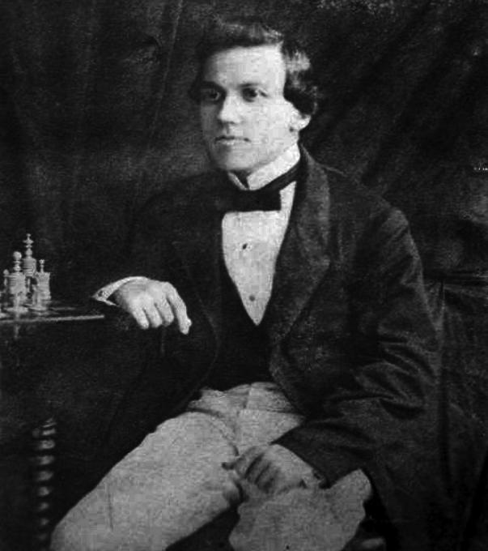

**Paul Morphy's Chess Elegance: A Romantic Ballet on the 64 Squares**

Greetings, chess aficionados. I am Paul Morphy, the Pride and Sorrow of Chess, and I welcome you to embark on a journey through the romantic era of chess—a realm where beauty, elegance, and boldness intertwine. Chess, to me, is not a battleground; it is a canvas for artistic expression, a ballet where each move is a dance step, and every combination is a sonnet. Join me as we unveil the top 10 tips and tricks that encapsulate my romantic approach to the royal game.

1. Rapid Development:

- Ignite the board with rapid development. Swiftly bring your pieces into play, allowing them to harmonize and perform a symphony of coordinated brilliance.

2. Open Lines and Diagonals:

- Embrace the openness of lines and diagonals. Carve pathways for your pieces to navigate freely, creating a canvas where tactical opportunities flourish.

3. King's Indian Attack Spirit:

- Infuse your games with the spirit of the King's Indian Attack. Boldly advance your pawns, creating a dynamic position that breathes life into your tactical ambitions.

4. Piece Sacrifices for Initiative:

- Sacrifice material for initiative. Let your pieces soar through the board with audacious sacrifices, creating positions where the initiative becomes your guiding star.

5. Queen's Gambit Dynamism:

- Channel the dynamism of the Queen's Gambit. Offer pawns strategically, provoking imbalances that allow your pieces to dance freely on the board.

6. Unpredictable Maneuvers:

- Unleash unpredictable maneuvers. Surprise your opponents with unorthodox piece placements, injecting a sense of wonder and confusion into the tactical landscape.

7. Strategic Outmaneuvering:

- Outmaneuver your opponents strategically. Exploit weak squares, disrupt their plans, and create positions that echo the elegance of a romantic chess ballet.

8. Intuitive Calculation:

- Trust your intuition in calculation. Let the beauty of your combinations flow organically, relying on your intuitive sense of harmony to guide your tactical brilliance.

9. Fluidity in King's Position:

- Allow fluidity in the king's position. Navigate the endgame with a dynamic king, using its versatility to participate actively and decisively.

10. Chess as a Creative Pursuit:

- View chess as a creative pursuit. Every move, every combination, is a stroke on the canvas of victory—a masterpiece that reflects your artistic interpretation of the game.

These tips are not just strategies; they are the embodiment of a romantic era where chess was an art form. As you traverse the chessboard, let elegance and imagination be your guiding lights. May your games mirror the enchanting beauty and boldness that define the spirit of Paul Morphy—a spirit that transformed chess into a symphony of artistic expression.

🚀 **Start the Adventure** Read this eBook and let the games begin!

📲 **Visit Our Website and Check Out the Classes** Go to [octagoncoach.com/chess-made-simple](https://www.octagoncoach.com/chess-made-simple/)